1.Sqoop import 13 tables

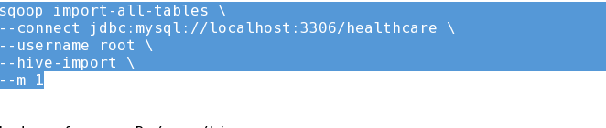

2.sqoop import screenshots

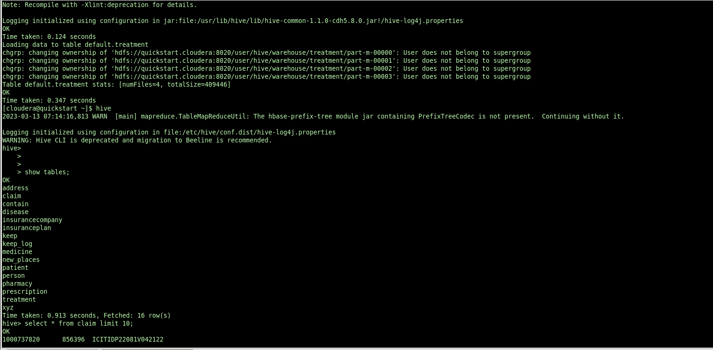

------------------------------------------------------query 1-------------------------------------------------------

1.external table creation and loading the query output

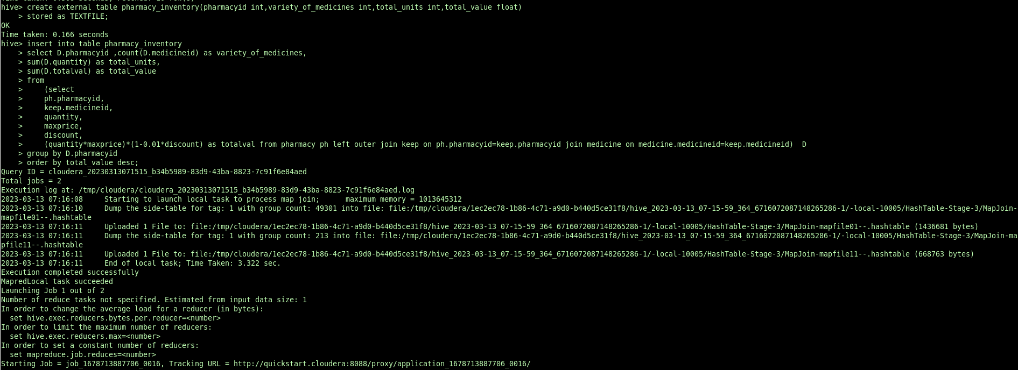

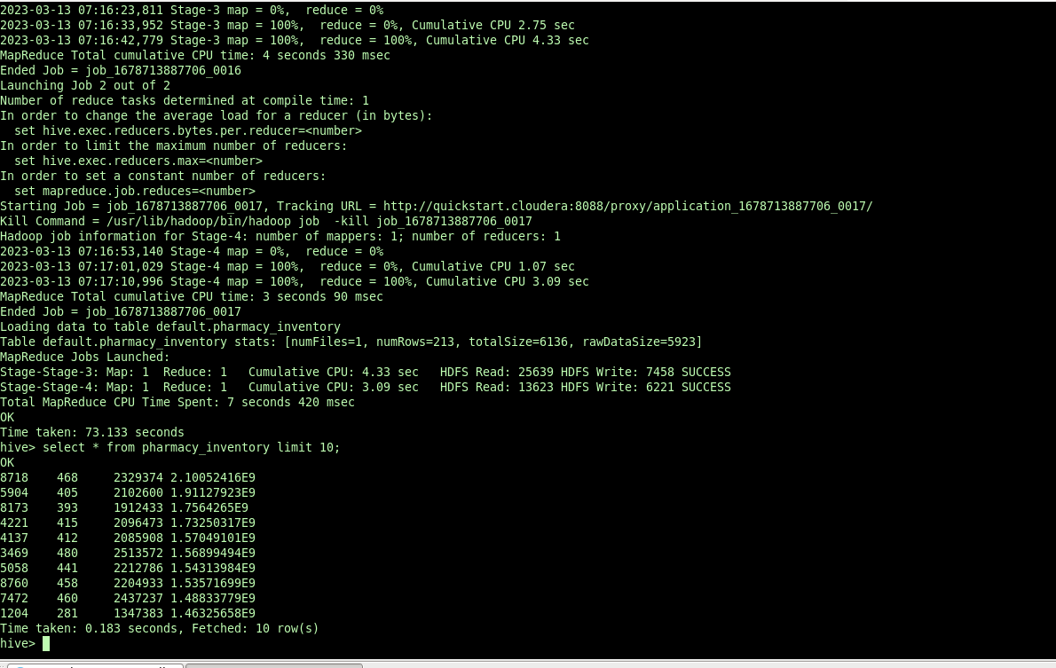

External table data from hdfs location

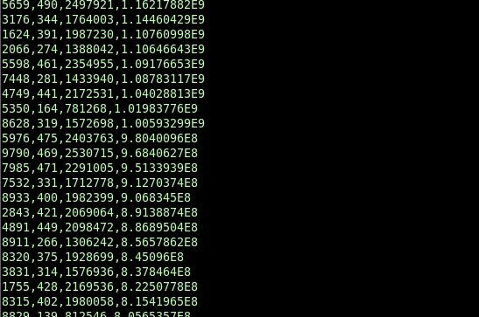

Exporting the outputs from external table to MySql database

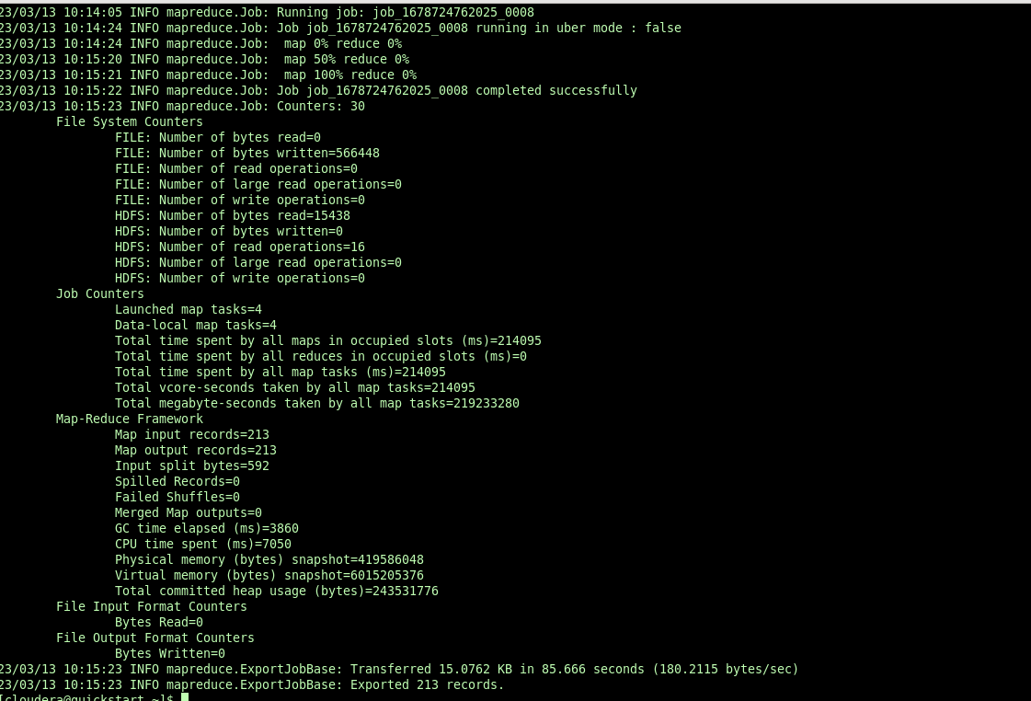

displaying the exported data from mysql database

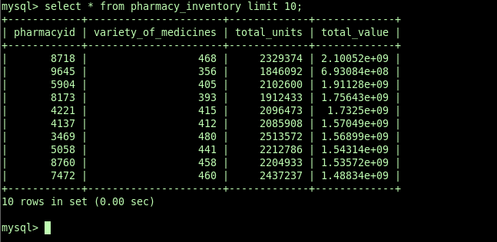

-------------------------------------------------query—2----------------------------------------------

1.creating external table to store query2 output

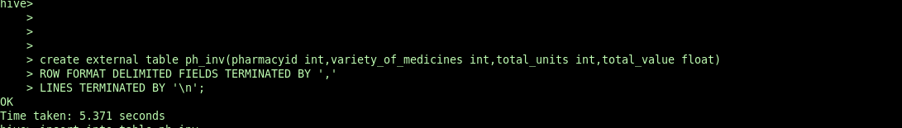

2.inserting query output to external table

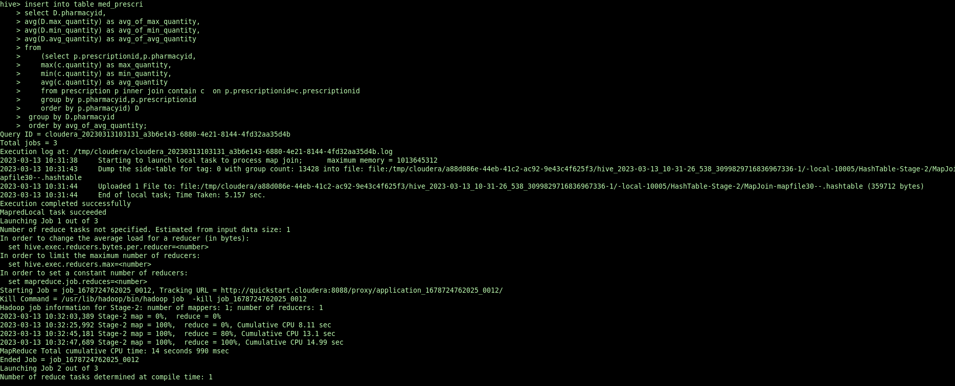

3.exporting external table to mysql db

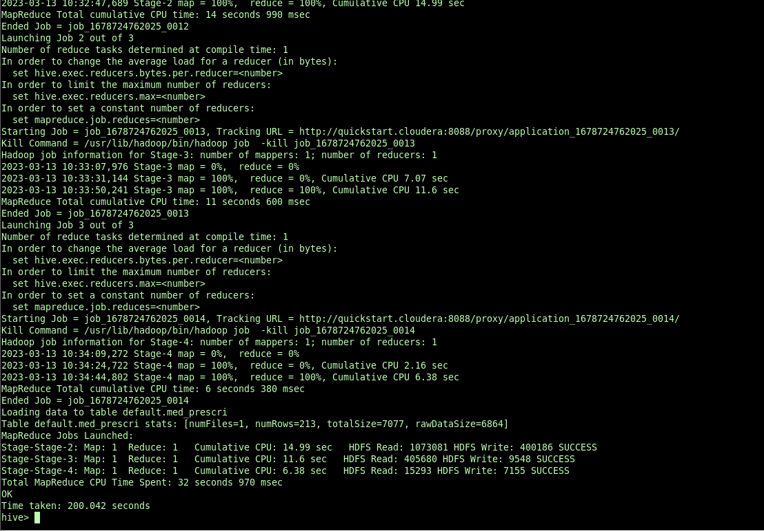

4.displaying exported data from mysql db

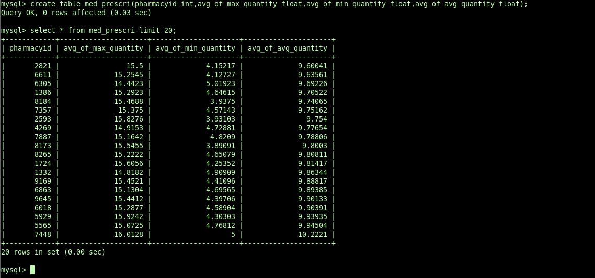

---------------------------------------------------------query 3------------------------

1.external table creation in hive

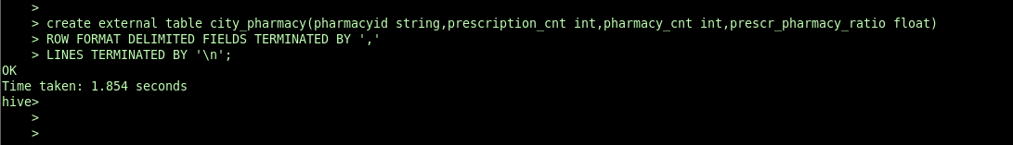

2.Storing the analysis results to hive external table

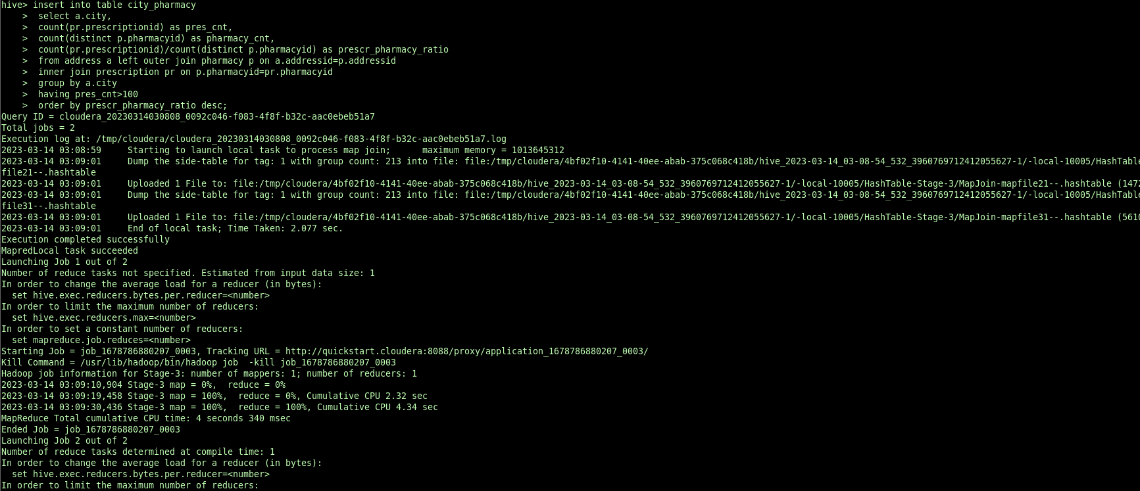

3.exporting results from hive table to city_pharmacy table in mysql database

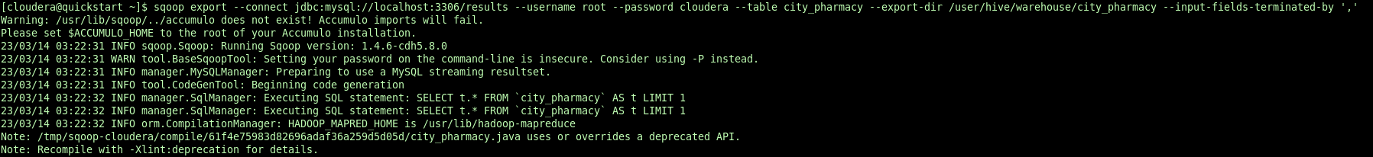

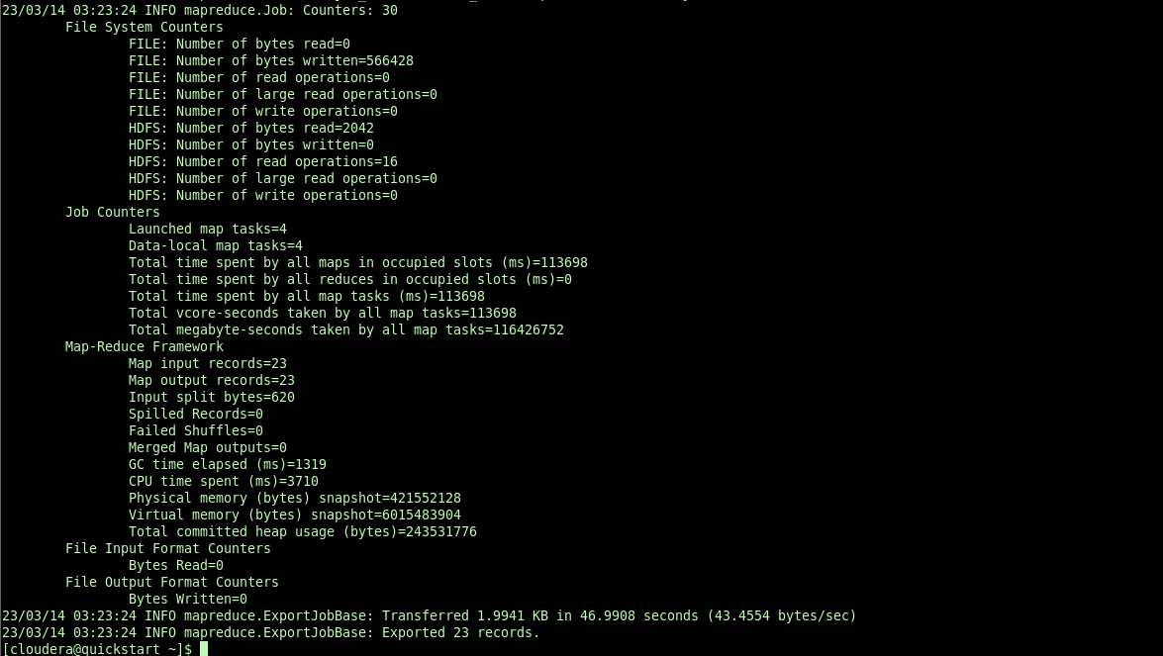

4.displaying the table in mysql db

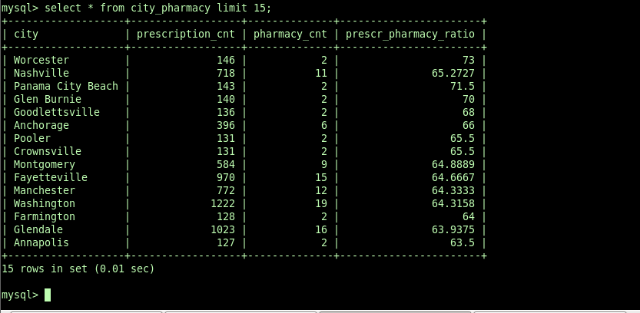

---------------------------------------------------------------------query4--------------------------------------

1.creating hive external table HD_pharmacy



2.inserting query result into hive external table

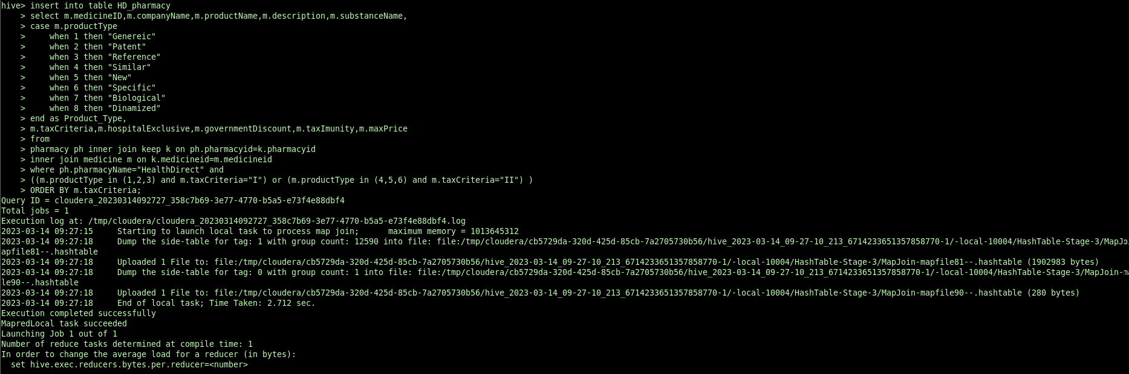

3.exporting table to mysql db

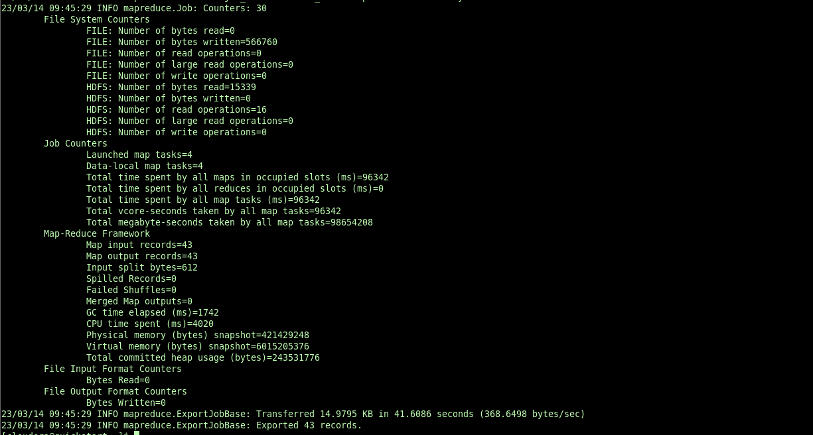

4.displaying result from mysql db

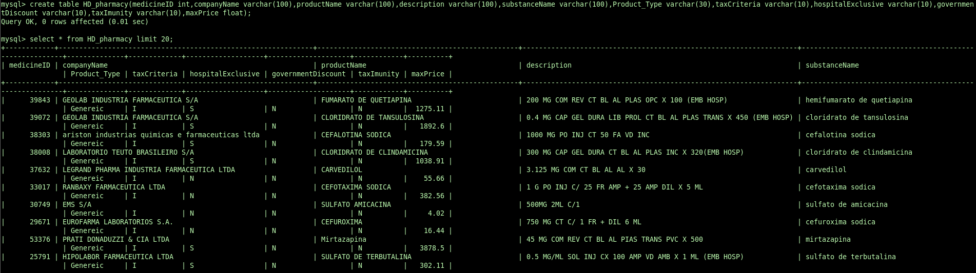

-----------------------------------------------------query5------------------------------------------------------

1.creating hive external table statewise_unclaimed

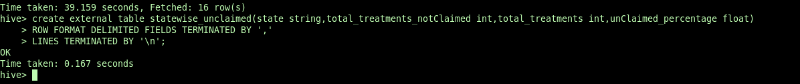

2.inserting query result into hive external table

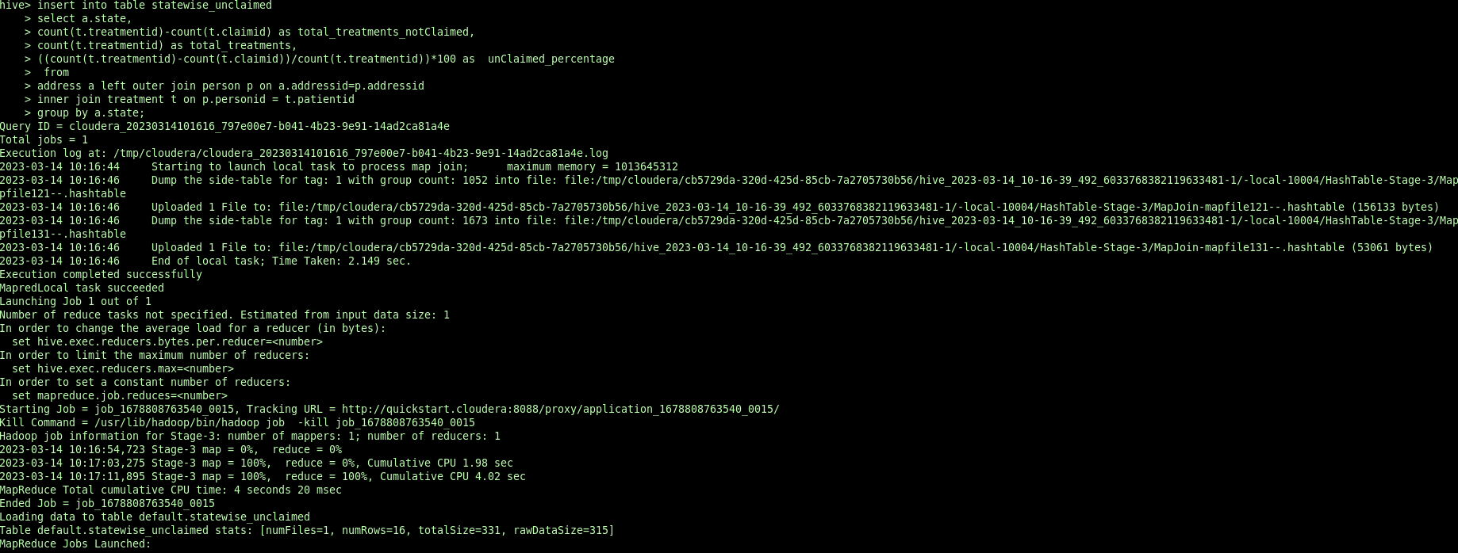

3.exporting data to mysql db

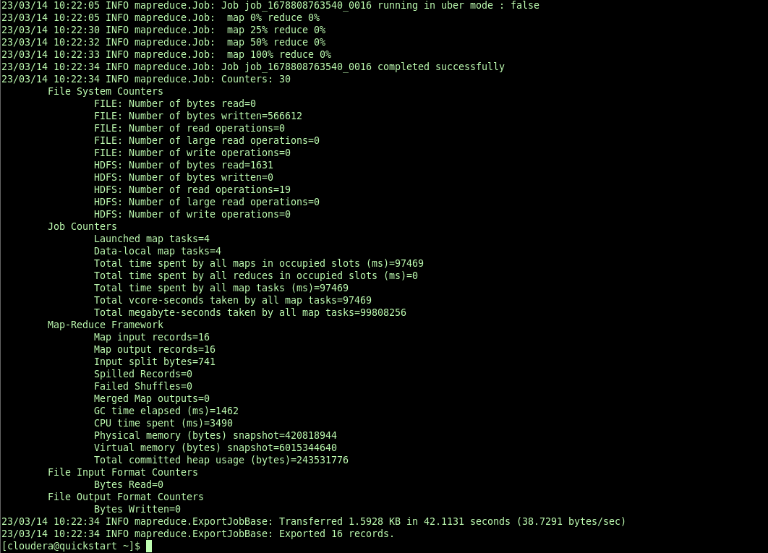

4.displaying data from mysqldb

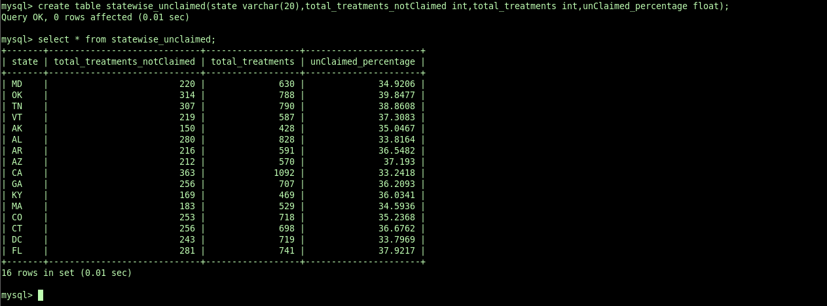

-------------------------------------------------------------query6-------------------------

1.creating hive external table

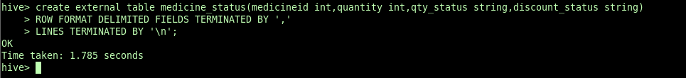

2.inserting results into hive external table

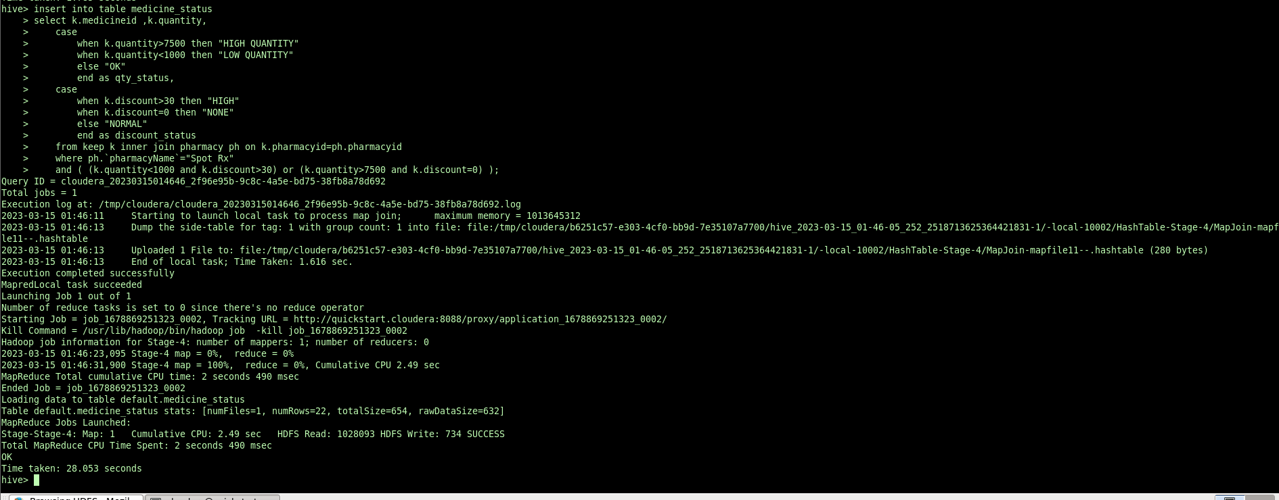

3.exporting results from hive external table to mysql db

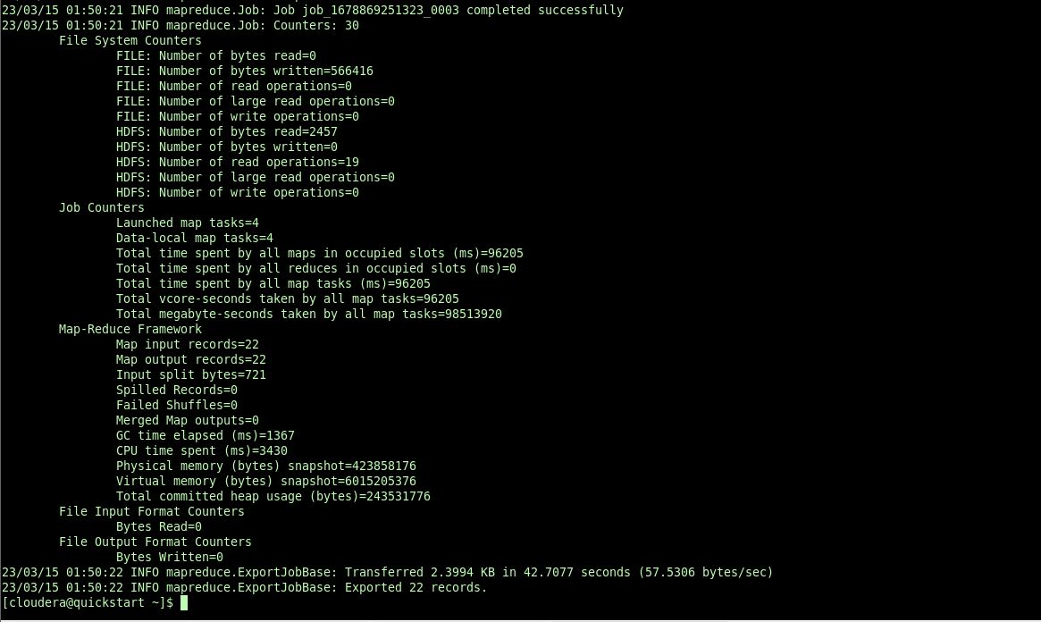

4.displaying exported table from mysql db

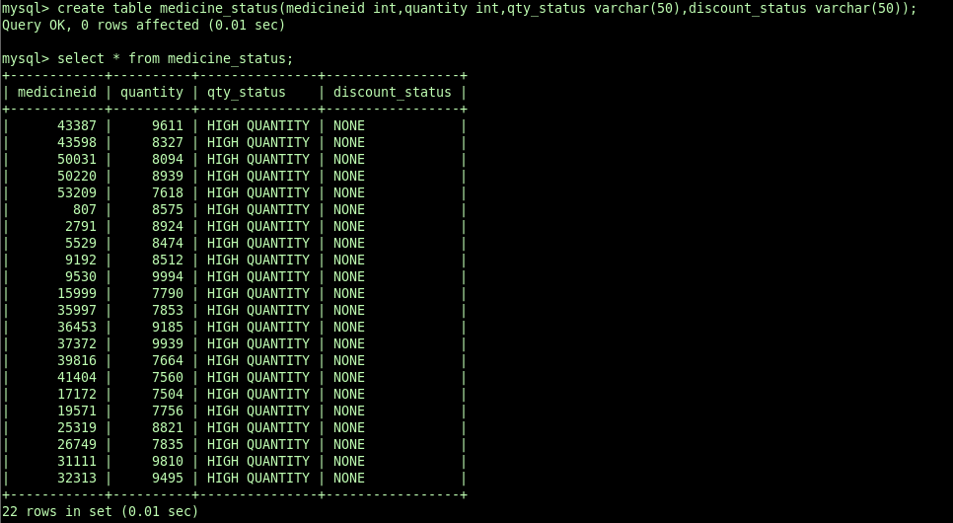

-------------------------------------------------query 7-------------------------------------

1.creating hive table for storing reults

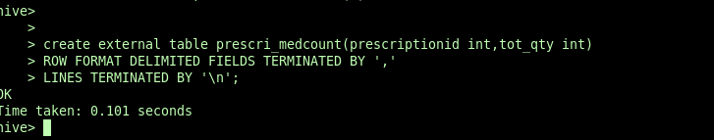

2.storing result in hive external table

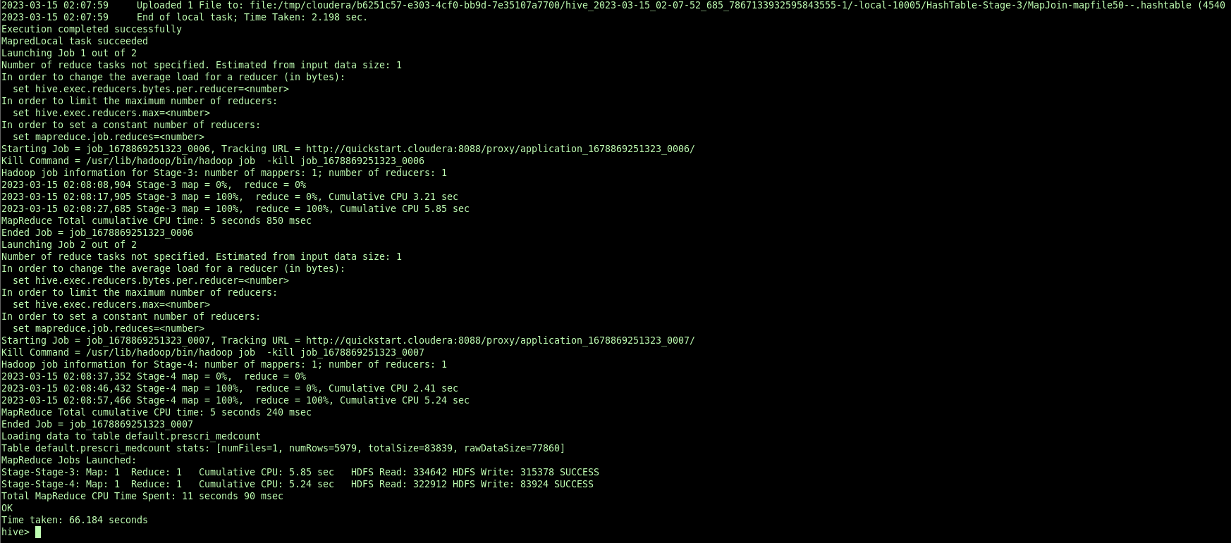

3.exporting data from hive external table to mysql db

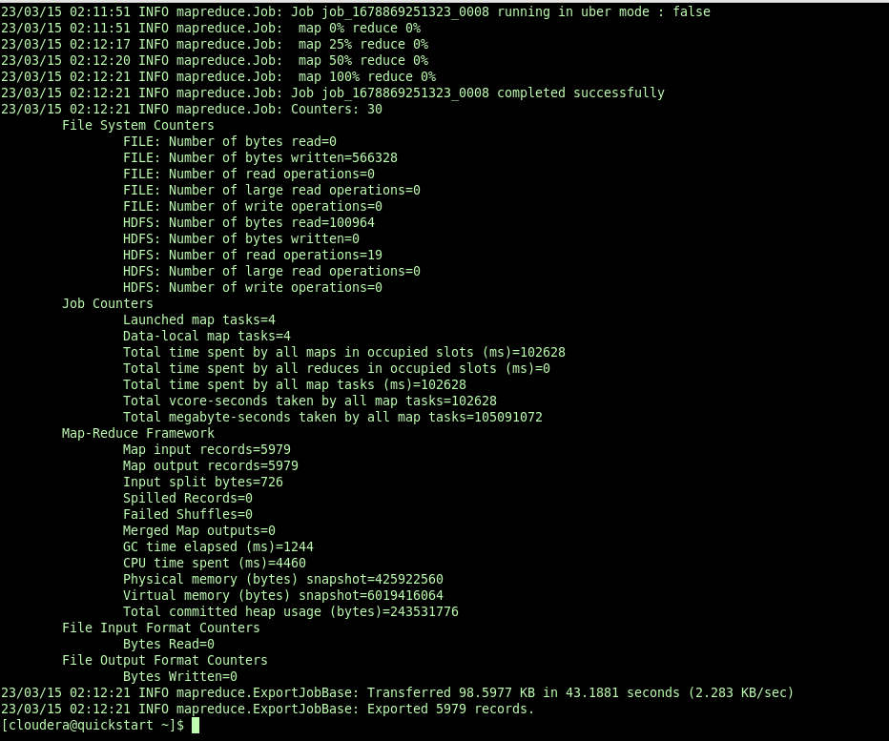

4.displaying exported table from mysql db

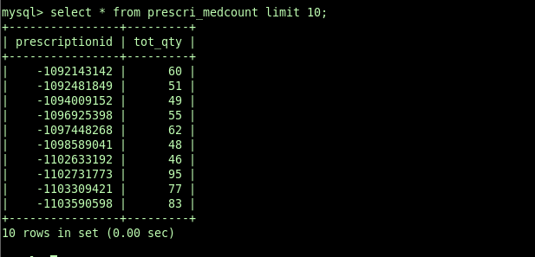

-------------------------------------partition table creation for address------------------

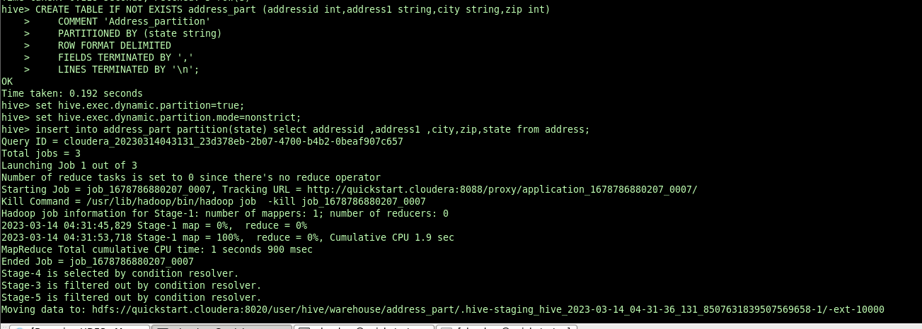

-----------------------------------------------query 8---------------------------------------

1.creating hive external table

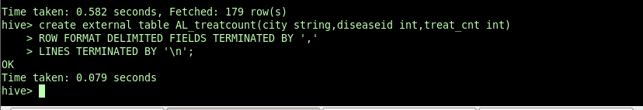

2.inserting results into hive external table

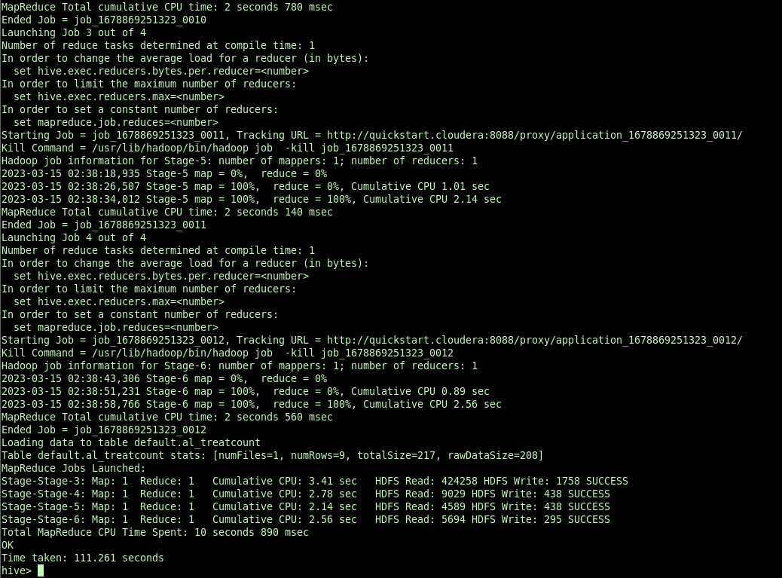

3.exporting data from hive external table to mysql db

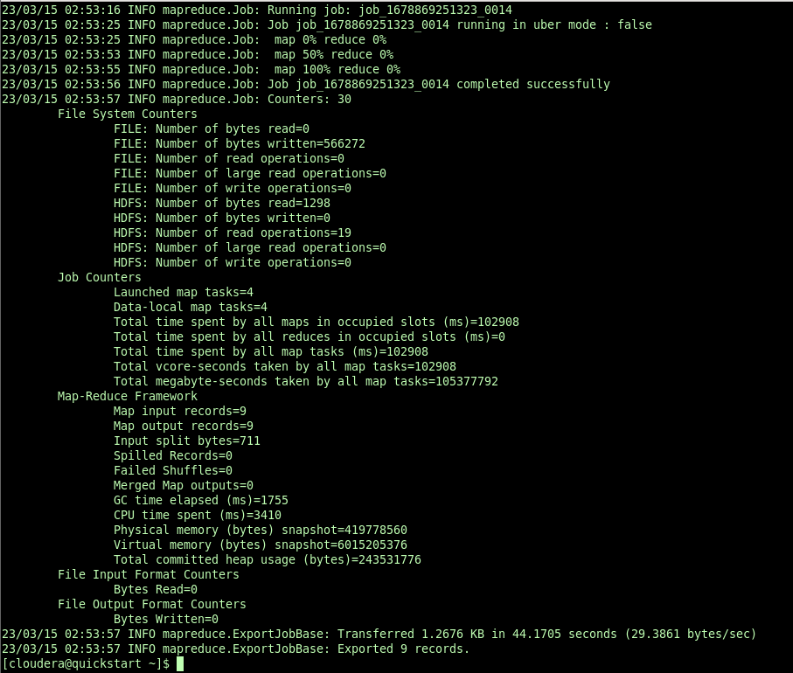

4.displaying exported data from mysqldb

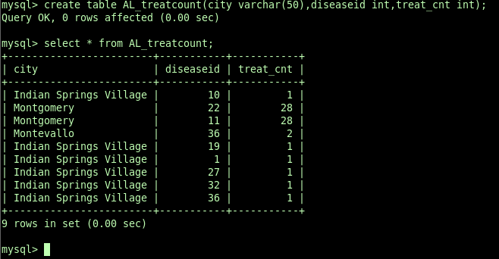

-----------------------------query 9--------------------------------------------------------

Partition on treatments

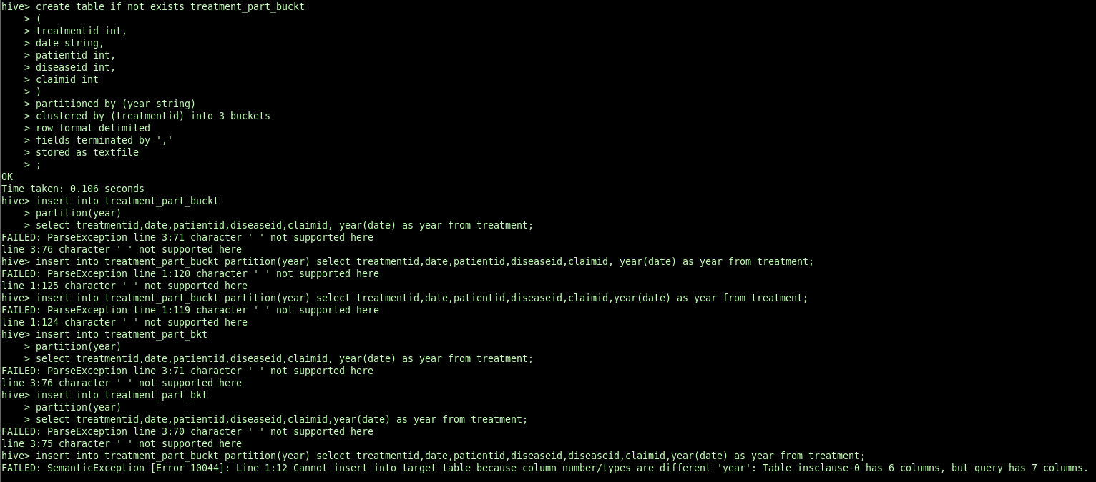

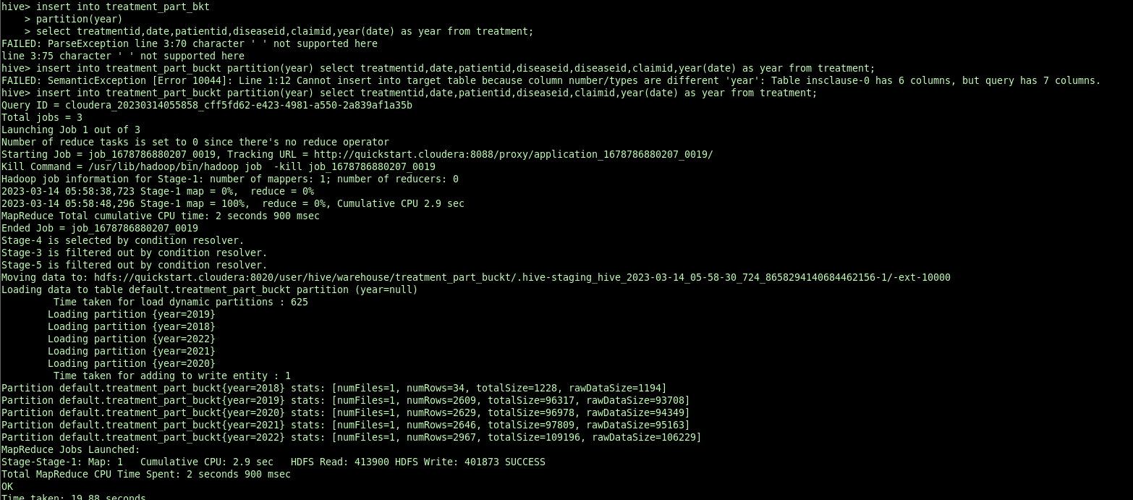

1.creating hive external for storing result



2.inserting results to hive external table

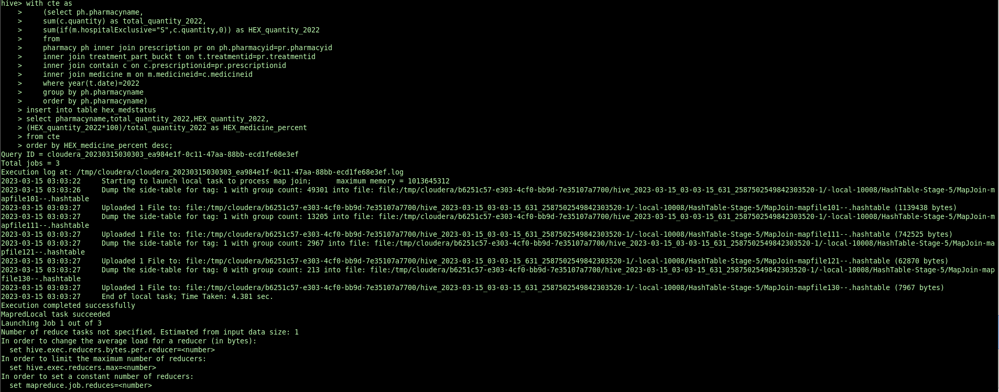

3.exporting data from hive table to mysqldb

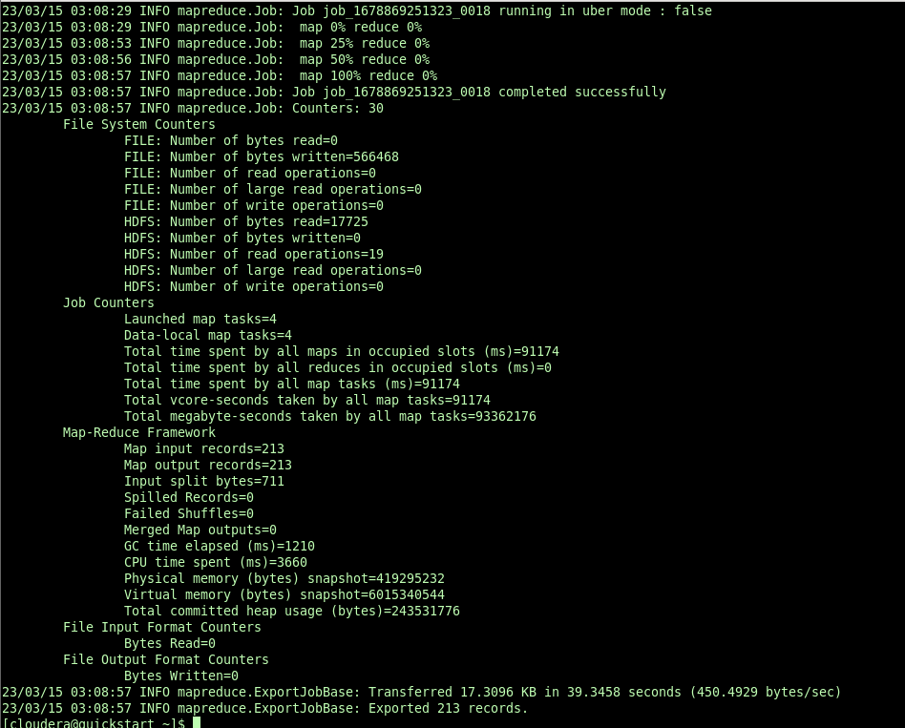

4.displaying data from mysql db

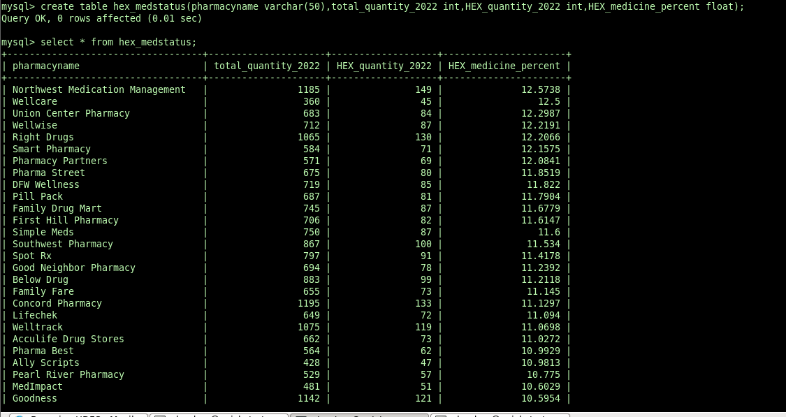

---------------------------------------------------query10-----------------------------------------------

1.creating hive external table

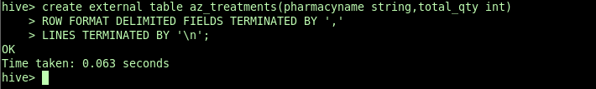

2.inserting result into hive external table

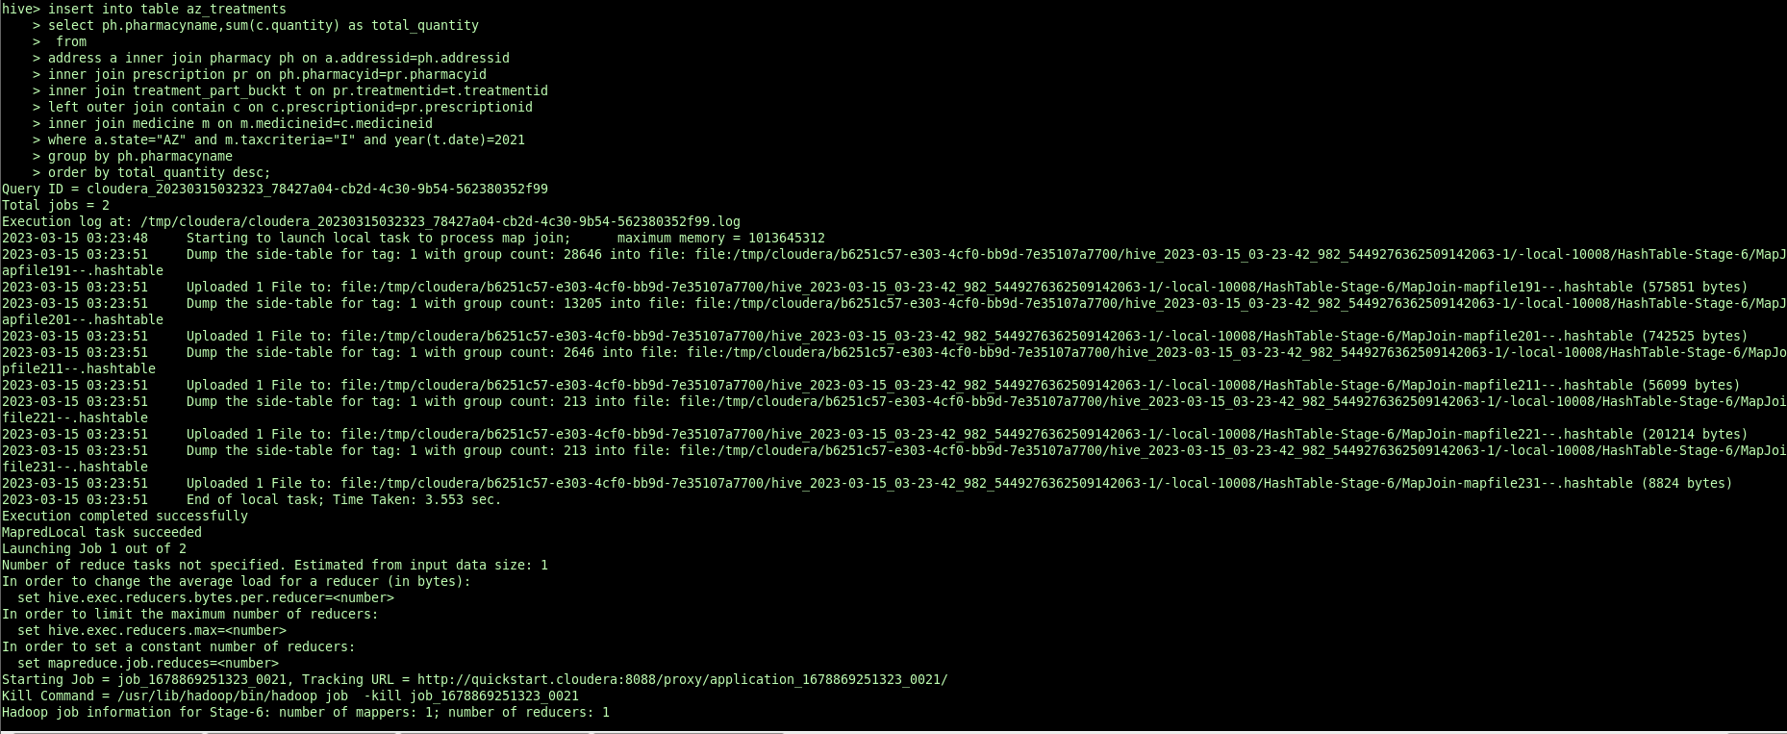

3.exporting data from hive external table to mysql db

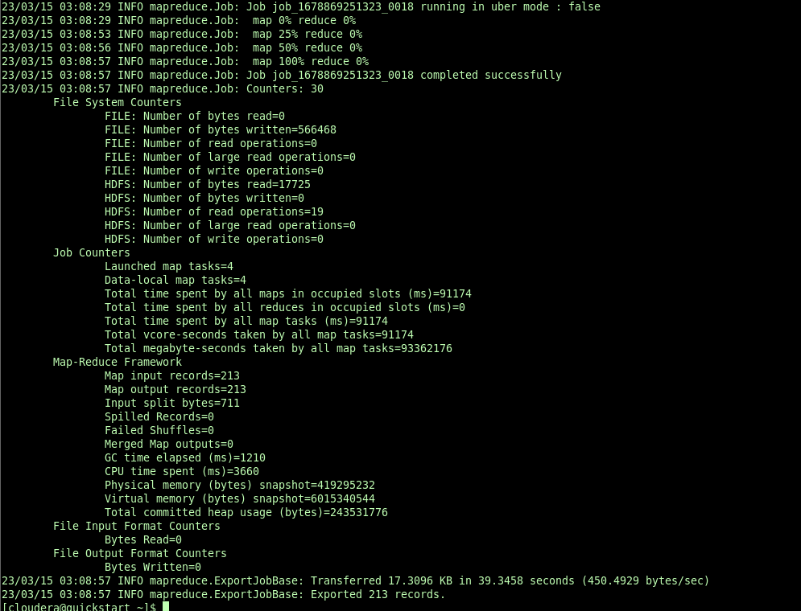

4.displaying data from mysqldb

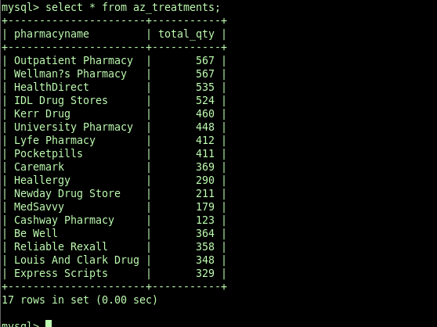

------------------------------------------------end----------------------------------------------